Problem Definition
Design and build a bridge out of balsa wood is at least 40cm long, bridging a gap of 35 centimetres and is capable of supporting 25 kilograms.
Requirements:
Physical requirements of bridge:
- Budget for all materials must not exceed $30
- Balsa must be no more than 3mm thick and 10mm wide
  - Strips may be laminated to create larger elements
- No fastening mechanisms apart from balsa glue may be used
- Total mass must not exceed 100g
- Bridge must be free standing and not rock on a level surface
- 5cm cube must be able to pass under structure
- 40cm x 2cm rod must fit under bridge
- Must include level roadway to the following constraints:
  - At least 40cm long
  - Suspended above 5cm mark
  - A wheeled vehicle must be able to move freely across length of roadway when given a gentle push
  - Roadway must not use individual pieces of balsa that are no more than 3mm thick or 10mm wide
- Testing frame must be able to be placed onto bridge with arms protruding from the bridge
Length restrictions:
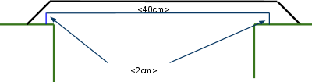
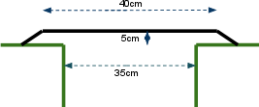
(at least 5cm high, 40cm flat length, 35cm gap) (board 40cm long, 2cm high must not touch structure)
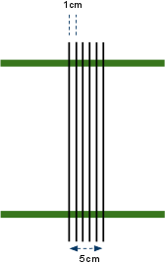
Width restrictions:
Individual piece restrictions:

(no more than 3mm thick and 10mm wide)
Time constraints:
- Week 4 - Project Conception stage completed
- Week 6 - Project Design stage completed
- Week 7 - Project Plan stage completed
- Week 12 - Project Implementation stage completed
Forms to be completed:
Project Conception - Team Work Compliance Form
Project Design - Team Work Compliance Form
Project Implementation - Team Work Compliance Form
Design Features
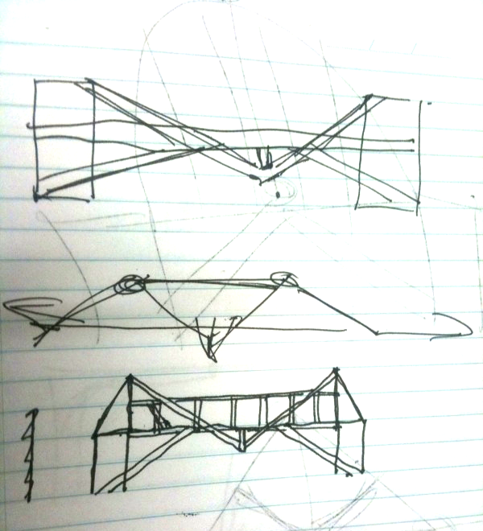
Due to the density of the wood being very light by nature, consideration will need to be given to how the 25kg mass added to the bridge will not compromise the structure. Particular attention should be focused towards the middle of the bridge where the weights will be placed, rather than at the ends since the weights will not need to 'travel' along the bridge.
A possible approach to solving the problem could include bracing the middle of the bridge as part of the framework. This would use a simple A frame type structure where the top of the frame would have beams extending to the middle of the platform, using the side supports to take more weight.

